
Tertiary Infotech Academy Pte Ltd
UEN: 201200696W
LESSON PLAN
For
Designing and Implementing Microsoft DevOps Solutions (AZ-400)
TGS Ref No: TGS-2024042605
Conducted by
Tertiary Infotech Academy Pte Ltd
UEN: 201200696W
Version 1

Document Version Control Record
Version Number | Effective Date of Release | Summary of Included Changes | Author
1 | 8 July 2026 | First AZ-400 lesson plan aligned to the generated PPT slide numbers and all 8 labs. | Tertiary Infotech Academy Pte Ltd

Course Details
Course Title | Designing and Implementing Microsoft DevOps Solutions (AZ-400)
TGS Ref No. | TGS-2024042605
Duration | 2 Days (16 training hours)
Training Hours | 9:00 AM - 6:00 PM, including lunch and short breaks
Delivery Mode | Instructor-led hands-on training
Learner Guide | LG-Designing and Implementing Microsoft DevOps Solutions (AZ-400).docx
Slide Deck | Designing and Implementing Microsoft DevOps Solutions (AZ-400)-v1.pptx
Lab Source | courseware/labs-source

Learning Outcomes
- Design DevOps processes with traceability from work item to deployment.
- Apply source control strategies with branches, pull requests and review practices.
- Create YAML CI pipelines with testing, artifacts and release controls.
- Use infrastructure as code, DevSecOps, monitoring and feedback practices in an end-to-end DevOps solution.

Delivery Diagram - DevOps Flow
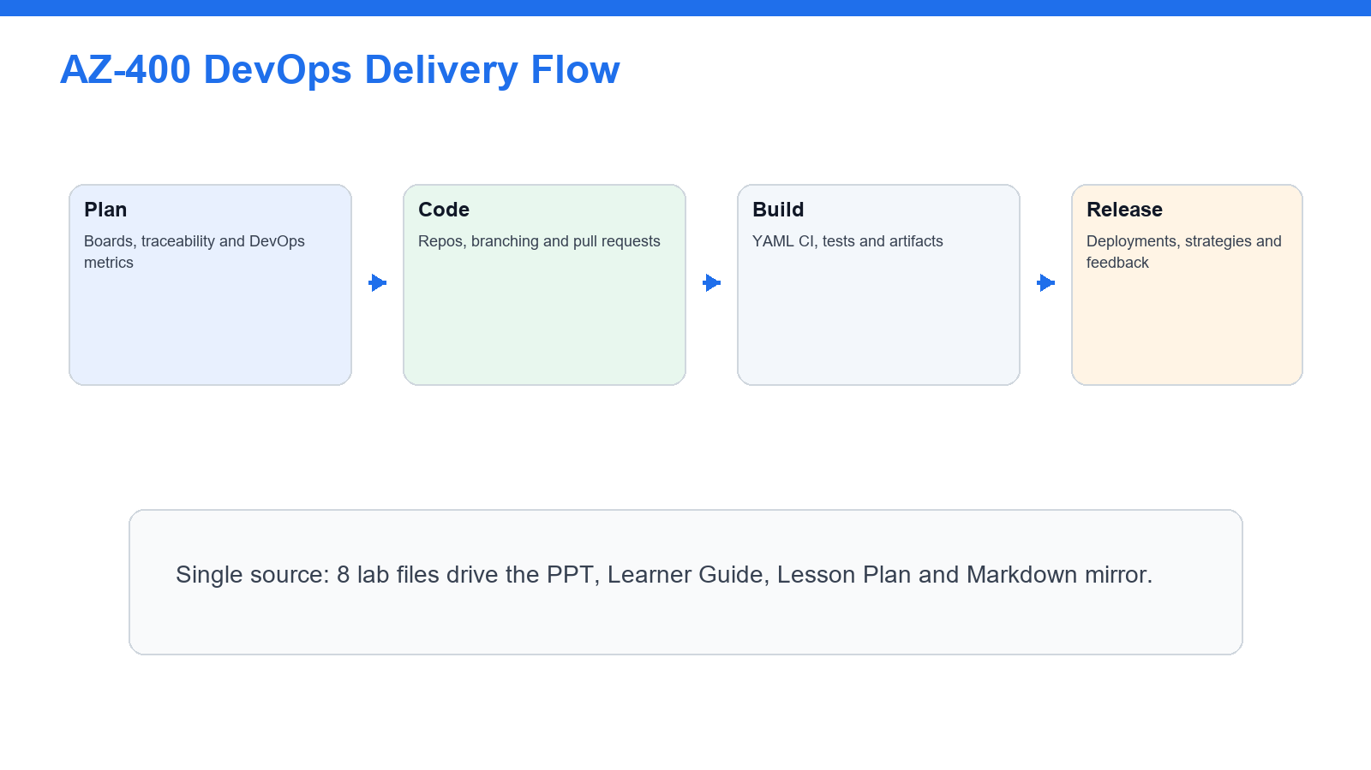
The delivery sequence follows the same order as the lab repository.

Delivery Diagram - Lab Map
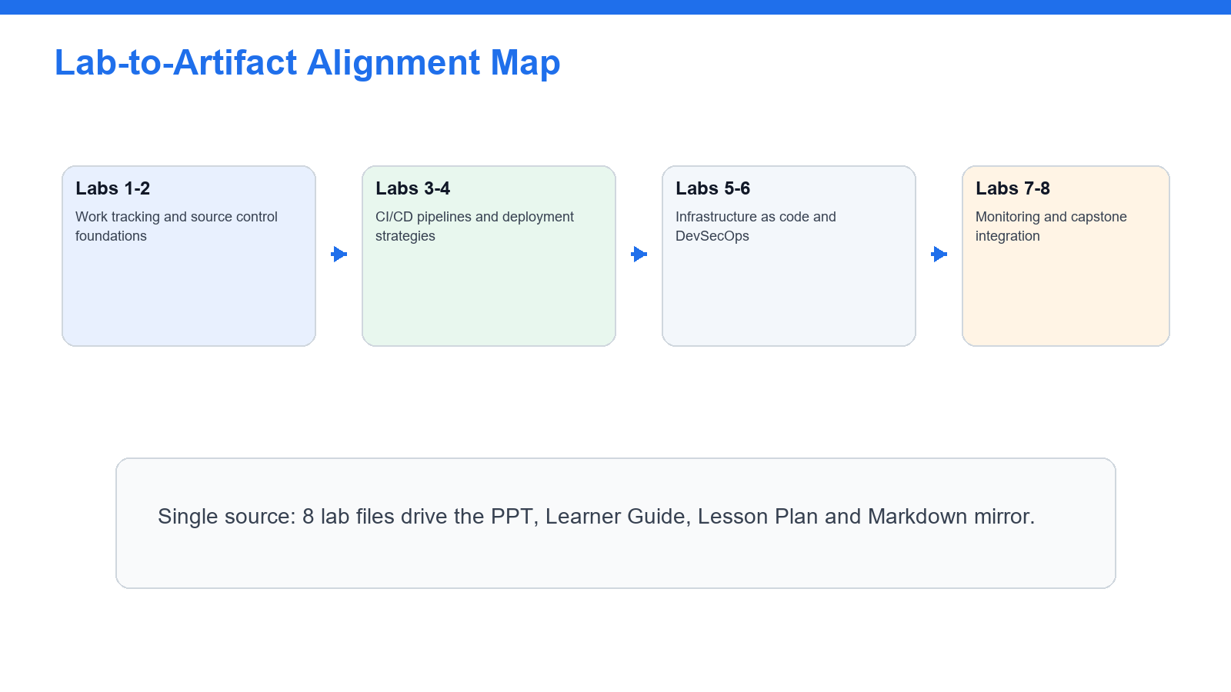
Each lesson-plan activity references the generated slide numbers.

Day 1 Schedule
Time | Activity / Topic | Lab | Slide No. | Duration
9:00-9:30 | Welcome, trainer introduction, attendance, ground rules and course objectives | - | 1-11 | 30 min
9:30-10:45 | DevOps processes, Boards and traceability | Lab 01 | 21-23 | 75 min
10:45-11:00 | Tea break | - | - | 15 min
11:00-12:30 | Source control, branching and pull requests | Lab 02 | 24-26 | 90 min
12:30-1:00 | Review: traceability and branching decisions | Labs 01-02 | 21-23, 24-26 | 30 min
2:00-3:30 | YAML CI pipelines, testing and artifacts | Lab 03 | 27-29 | 90 min
3:30-3:45 | Tea break | - | - | 15 min
3:45-5:30 | Release pipelines and deployment strategies | Lab 04 | 30-32 | 105 min
5:30-6:00 | Day 1 recap and evidence check | Labs 01-04 | 21-23-30-32 | 30 min

Day 2 Schedule
Time | Activity / Topic | Lab | Slide No. | Duration
9:00-10:30 | Infrastructure as Code with Bicep and templates | Lab 05 | 33-35 | 90 min
10:30-10:45 | Tea break | - | - | 15 min
10:45-12:15 | DevSecOps, secrets and compliance scanning | Lab 06 | 36-38 | 90 min
12:15-1:00 | Security and governance review | Labs 05-06 | 33-35, 36-38 | 45 min
2:00-3:30 | Instrumentation, monitoring, KQL and feedback | Lab 07 | 39-41 | 90 min
3:30-3:45 | Tea break | - | - | 15 min
3:45-5:15 | Capstone: end-to-end DevOps solution | Lab 08 | 42-44 | 90 min
5:15-6:00 | Assessment briefing, evidence submission, cleanup and course close | Labs 01-08 | 1-45 | 45 min

PPT Slide Number Map
Slide No. | Slide / Activity
1 | Cover
2 | COURSE ADMINISTRATION - Welcome & Housekeeping
3 | TRAQOM + SSG DIGITAL ATTENDANCE - Digital Attendance (Mandatory)
4 | YOUR TRAINER + GENERAL - About the Trainer
5 | YOUR TRAINER - About the Trainer
6 | ICE-BREAKER - Let's Know Each Other
7 | HOUSEKEEPING - Ground Rules
8 | COURSE PORTAL - LMS / TMS
9 | GET THE LABS - Download the Course Labs
10 | SCHEDULE - Lesson Plan - 2 Days, 8 hours/day
11 | WHAT YOU'LL ACHIEVE - Learning Outcomes
12 | BRIEFING FOR ASSESSMENT - Assessment Briefing
13 | PRACTICE ASSESSMENT - Take the Online AZ-400 Practice Assessments
14 | ON ASSESSMENT DAY - Assessment Flow
15 | TOPIC 1 - Azure DevOps Delivery Lifecycle
16 | OVERVIEW - AZ-400 is about designing delivery systems
17 | FEATURES - Core DevOps Capabilities Practised
18 | WHY DEVOPS - DevOps connects work, code and operations
19 | THE PLATFORM - Azure DevOps and GitHub
20 | MOTIVATION - Why automate delivery?
21 | Lab 01 overview
22 | Lab 01 step
23 | Lab 01 test
24 | Lab 02 overview
25 | Lab 02 step
26 | Lab 02 test
27 | Lab 03 overview
28 | Lab 03 step
29 | Lab 03 test
30 | Lab 04 overview
31 | Lab 04 step
32 | Lab 04 test
33 | Lab 05 overview
34 | Lab 05 step
35 | Lab 05 test
36 | Lab 06 overview
37 | Lab 06 step
38 | Lab 06 test
39 | Lab 07 overview
40 | Lab 07 step
41 | Lab 07 test
42 | Lab 08 overview
43 | Lab 08 step
44 | Lab 08 test
45 | Wrap-up

